1) Ecrivez les légendes de ces vignettes :

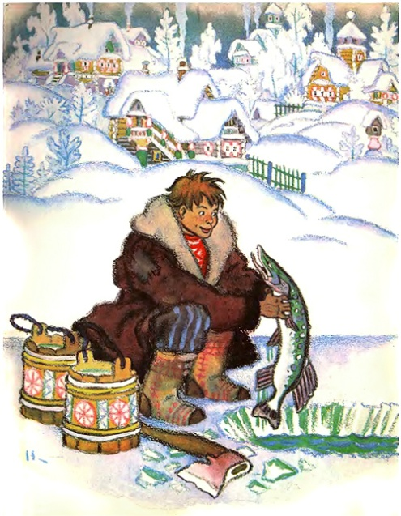  _______________________________  _______________________________ | 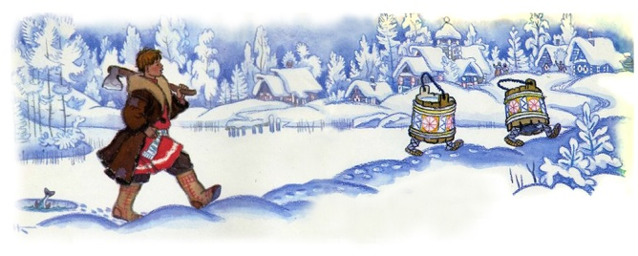___________________________________  ___________________________________
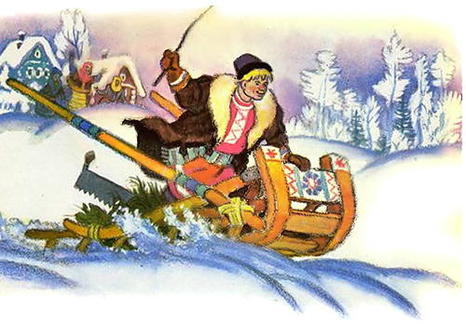
_________________________________
_________________________________

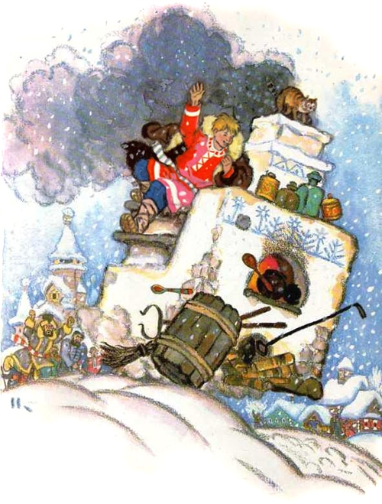  ______________________________  ______________________________ | 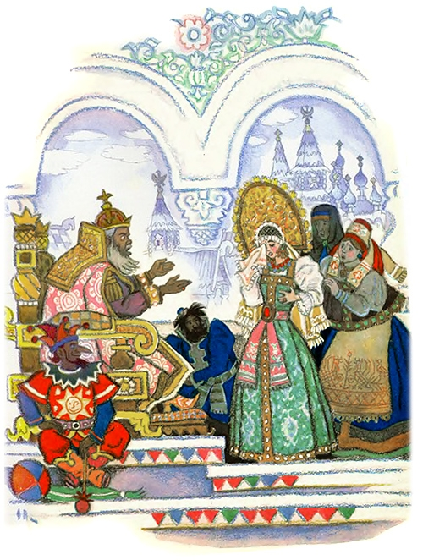  ____________________________  ____________________________

2). Imaginez et rédigez la fin du conte :
__________________________________________________________________________________________________________________________________________________________________________________________________________________________________________________________________________________________________________________________________________________________________________________

